### **Monarch – AngularJS Bootstrap 3 and 4**

### **( alpha ) Admin Template - Documentation**

***Overview***

First of all Monarch is a front-end [Bootstrap](http://getbootstrap.com/) HTML 5 Admin Template. Using the latest standards and technologies Monarch brings a fresh feeling in this area and can be used for admin or backend apps. With a modern and minimalistic look Monarch also has a [AngularJS](https://angularjs.org/) version for developers that wants to take this template even further. And as a final touch in our latest update we added a Bootstrap 4 for who wants to be in trend with the latest technologies on the market but since Bootstrap 4 it only exists in Alpha version, we let you to choose between 3 or 4.

**Author :** [**AgileUI**](https://agileui.com/)

***Packaging***

Once you opened the package, it should look something like that :

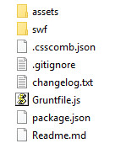

At a first look you can see ***assets*** folder. Once we opened it we’ll have this view :

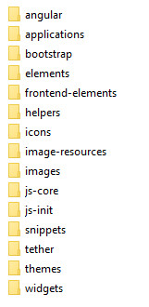

***\* for who’s interested and wants to take this template further, first folder on the list is AngularJS content.***

***\* also in this folder we find all we need in terms of CSS and Javascript content.***

Now maybe you’re wondering where the ***HTML pages*** are. Well, those and also all you need to start developing your next project are located in ***production*** file. Because it takes too much space that’s hidden at first ( via .gitignore ) file.

In order to unlock this you must follow a few steps and will take it one by one.

1. First of all we need to install [node.js](https://nodejs.org/) all you need to know about it you can find it there.

2. Once we have node installed we can go to the second step but for this one we must use a command prompt, in this case ***bash*** and when you landed to the main package ( you clicked to open the monarch folder ) just click right and you’ll see “Git Bash here” ( like the example above ) :

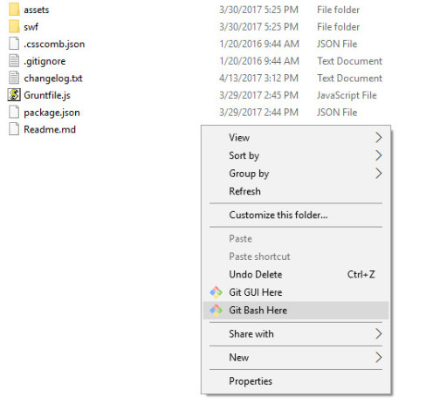

3. Once we have ***bash*** openedwe must install [npm](https://www.npmjs.com/) , all you need to know about it you can read there. Next move is to type **npm install** in there and wait a few moments. After this step a folder called “node_modules” should appear, if you have it, you’re on the good road until now.

4. Next step is to install Grunt client.

[Grunt](https://gruntjs.com/) is a task runner and all that he does is to make your life easier but all you need to know about it you can find it here. For this one we must type **npm install grunt-cli** and wait a few.

5. Next move would be to install grunt. For this all we need to do is type **npm install grunt** and wait a few seconds.

6. The next and last step is to initialize Grunt. For that just type **grunt** and that’s it.

*\* If those steps are followed properly , after Grunt initialization a folder called* ***production*** *should be there now.*

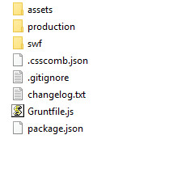

Once you opened the ***production*** file , it should look like this :

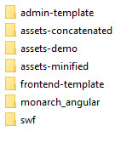

*\***in* ***admin-template*** *- HTML pages.*

*\* in* ***fronted-template*** *- HTML pages used for the frontend version.*

*\* in* ***monarch-angular*** - the AngularJS files.

* in ***assets-concatenated*** you can find concatenated CSS and JS ( more CSS/JS files are combined in one )

* in ***assets-minified*** *CSS/JS files are the same but the code is combined in one line*

*\* last two points are accomplished via Grunt.*

*\* regarding* [*AngularJS*](https://angularjs.org/) *it depends on user knowledges so we’re not gonna debate it to much here. If you’re new to it , all you need to know you can find it here.*

If you need further assistance you can find us here : [contact@agileui.com](mailto:contact@agileui.com)